|  |  |
| --- | --- |
| **NAME:** | Harshal Chawan |
| **UID:** | 2021300019 |
| **SUBJECT** | Design and Analysis of Algorithm |
| **EXPERIMENT NO :** | 09 |
| **DATE OF PERFORMANCE** | 17/04/2023 |
| **DATE OF SUBMISSION** | 24/04/2023 |
| **AIM:** | To use branch and bound strategy to solve 15 puzzle problem. |
| **PROBLEM STATEMENT 1:** | **15 puzzle problem** |
| **ALGORITHM and THEORY:** | .If N is odd, then puzzle instance is solvable if number of inversions is even in the input state.   1. If N is even, puzzle instance is solvable if    * the blank is on an even row counting from the bottom (second-last, fourth-last, etc.) and number of inversions is odd.    * the blank is on an odd row counting from the bottom (last, third- last, fifth-last, etc.) and number of inversions is even. 2. For all other cases, the puzzle instance is not solvable. |

|  |  |
| --- | --- |
| **PROGRAM:** | #include<stdio.h> |
|  | int m=0,n=4; |
|  | int cal(int temp[10][10],int t[10][10]) |
|  | { |
|  | int i,j,m=0; |
|  | for(i=0;i < n;i++) |
|  | for(j=0;j < n;j++) |
|  | { |
|  | if(temp[i][j]!=t[i][j]) |
|  | m++; |
|  | } |
|  | return m; |
|  | } |
|  | int check(int a[10][10],int t[10][10]) |
|  | { |
|  | int i,j,f=1; |
|  | for(i=0;i < n;i++) |
|  | for(j=0;j < n;j++) |
|  | if(a[i][j]!=t[i][j]) |
|  | f=0; |
|  | return f; |
|  | } |
|  | void main() |
|  | { |
|  | int p,i,j,n=4,a[10][10],t[10][10],temp[10][10],r[10][10]; |
|  | int m=0,x=0,y=0,d=1000,dmin=0,l=0; |
|  | printf("\nEnter the matrix to be solved,space with zero :\n"); |
|  | for(i=0;i < n;i++) |

for(j=0;j < n;j++)

scanf("%d",&a[i][j]);

printf("\nEnter the target matrix,space with zero :\n"); for(i=0;i < n;i++)

for(j=0;j < n;j++)

scanf("%d",&t[i][j]);

printf("\nEntered Matrix is :\n"); for(i=0;i < n;i++)

{

for(j=0;j < n;j++)

printf("%d\t",a[i][j]); printf("\n");

}

printf("\nTarget Matrix is :\n"); for(i=0;i < n;i++)

{

for(j=0;j < n;j++)

printf("%d\t",t[i][j]); printf("\n");

}

while(!(check(a,t)))

{

l++; d=1000;

for(i=0;i < n;i++)

for(j=0;j < n;j++)

{

if(a[i][j]==0)

{

x=i;

y=j;

}

}

//To move upwards for(i=0;i < n;i++)

for(j=0;j < n;j++)

temp[i][j]=a[i][j];

if(x!=0)

{

p=temp[x][y]; temp[x][y]=temp[x-1][y]; temp[x-1][y]=p;

}

m=cal(temp,t); dmin=l+m; if(dmin < d)

{

d=dmin; for(i=0;i < n;i++)

for(j=0;j < n;j++)

r[i][j]=temp[i][j];

}

//To move downwards for(i=0;i < n;i++)

for(j=0;j < n;j++)

temp[i][j]=a[i][j];

if(x!=n-1)

{

p=temp[x][y]; temp[x][y]=temp[x+1][y]; temp[x+1][y]=p;

}

m=cal(temp,t); dmin=l+m; if(dmin < d)

{

d=dmin; for(i=0;i < n;i++)

for(j=0;j < n;j++)

r[i][j]=temp[i][j];

}

//To move right side for(i=0;i < n;i++)

for(j=0;j < n;j++)

temp[i][j]=a[i][j];

if(y!=n-1)

{

p=temp[x][y]; temp[x][y]=temp[x][y+1]; temp[x][y+1]=p;

}

m=cal(temp,t); dmin=l+m; if(dmin < d)

{

d=dmin; for(i=0;i < n;i++)

for(j=0;j < n;j++)

r[i][j]=temp[i][j];

}

//To move left for(i=0;i < n;i++)

for(j=0;j < n;j++)

|  |  |  |  |
| --- | --- | --- | --- |
|  |  |  | temp[i][j]=a[i][j]; |
|  |  | if(y!=0) |
|  |  | { |
|  |  | p=temp[x][y]; |
|  |  | temp[x][y]=temp[x][y-1]; |
|  |  | temp[x][y-1]=p; |
|  |  | } |
|  |  | m=cal(temp,t); |
|  |  | dmin=l+m; |
|  |  | if(dmin < d) |
|  |  | { |
|  |  | d=dmin; |
|  |  | for(i=0;i < n;i++) |
|  |  | for(j=0;j < n;j++) |
|  |  | r[i][j]=temp[i][j]; |
|  |  | } |
|  |  | printf("\nCalculated Intermediate Matrix Value :\n"); |
|  |  | for(i=0;i < n;i++) |
|  |  | { |
|  |  | for(j=0;j < n;j++) |
|  |  | printf("%d\t",r[i][j]); |
|  |  | printf("\n"); |
|  |  | } |
|  |  | for(i=0;i < n;i++) |
|  |  | for(j=0;j < n;j++) |
|  |  | { |
|  |  | a[i][j]=r[i][j]; |
|  |  | temp[i][j]=0; |
|  |  | } |
|  |  | printf("Minimum cost : %d\n",d); |
|  | } |  |
| } |  |  |

**OUTPUT:**

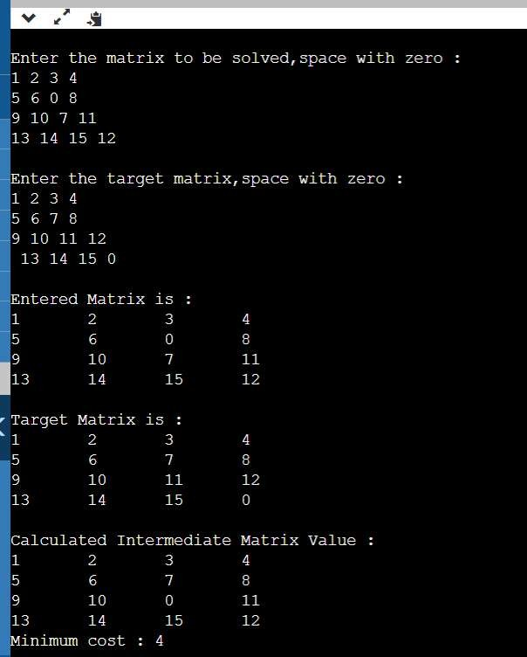

**CONCLUSION:**

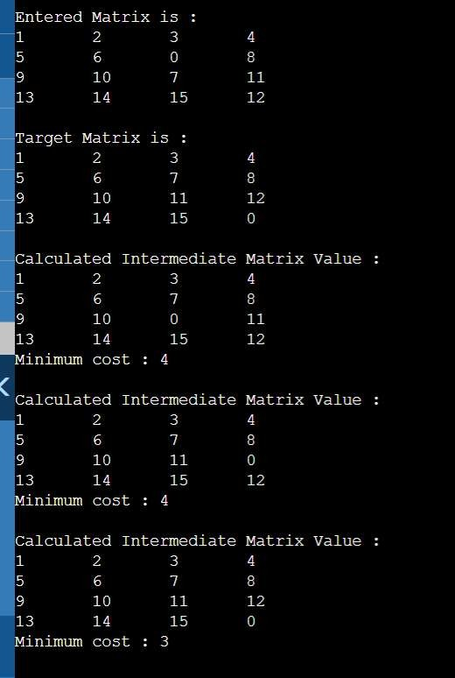

By performing above experiment I have understood 15 puzzle problem and I have been able to rearrange the puzzle.